***UNIT-III***

***Epistemology of Engineering***

Science, Engineering, and Technology are often confused with each other. All three are closely related but mean different things. In this post, we have tried to bring out the differences between science, engineering, and technology. Let’s start with a quote that brings out the difference between Science & Engineering:

“Scientists study the world as it is; engineers create the world that has never been.”

—Theodore von Kármán

As per the quote, we can observe that science is a study of the natural world while [Engineering](http://www.durofy.com/category/technology/engineering-tech/) is creating new things based on that study. However, I would like to modify the quote in order to bring out a comparison between science, engineering and [technology](http://www.durofy.com/category/technology/):

“Science is the study of the natural world as it is; engineering is creating new tools, devices, and processes based on **scientific**knowledge; technology is the sum total of all the **engineered** tools, devices and processes available.”

In the above quote, we can clearly see the difference as well as the interconnection between science, engineering, and technology. This can be explained using the image that follows:

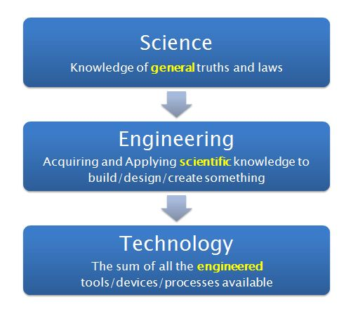

Now that we know the basic definitions and the overall comparison between the three, let’s move to a set of alternate differences between them. The differences below may seem redundant, and that’s because they are. They are all different ways of saying the same thing. Choose whichever appeals you the most:

1. Science is knowledge of the natural world put together, Engineering is creation based on the scientific knowledge put together, and Technology is the set of engineered creations put together.

2. Science comes from observation of the world, Engineering comes from aquiring and applying knowledge, and Technology comes from repeated application and approval of the engineered tools.

3. Science is about creating meaning of natural phenomenon, Engineering is about creating new devices, tools and processes, and Technology is about creating a collection of engineered and tested tools for the mankind.

***Four Dimensions of Engineering:***

In the discussion of engineering knowledge it is helpful to think of engineering as comprising four major dimensions (Fig. 1): the dimensions of the basic sciences, of the social sciences, of design, and of practical accomplishment. This lets us think of the engineer as a professional who combines, in variable proportions, the qualities of a scientist, a sociologist, a designer, and a doer.



The dimension inspired by the basic sciences views engineering as the application of the natural and exact sciences, stressing the values of logics and rigour, and seeing knowledge as produced through analysis and experimentation. Research is the preferred modus operandi of this dimension, where the discovery of first principles is seen as the activity leading to higher recognition. The social dimension of engineering sees engineers not just as technologists, but also as social experts, in their ability to recognize the eminently social nature of the world they act upon and the social complexity of the teams they belong to. The creation of social and economic value and the belief in the satisfaction of end users emerge as central values in this dimension of engineering.

The design dimension sees engineering as the art of design. It values systems thinking much more than the analytical thinking that characterizes traditional science. Its practice is founded on holistic, contextual, and integrated visions of the world, rather than on partial visions. Typical values of this dimension include exploring alternatives and compromising. In this dimension, which resorts frequently to non-scientific forms of thinking, the key decisions are often based on incomplete knowledge and intuition, as well as on personal and collective experiences. The fourth mode views engineering as the art of getting things done, valuing the ability to change the world and overcoming complexity with flexibility and perseverance. It corresponds to the art of the homo faber, in its purest expression, and to the ability to tuck up one’s sleeves and get down to the nitty-gritty. In this dimension, the completed job, which stands before the world, leads to higher recognition.

***RAISEC Model:***

In the 1950s, John Holland theorized that personality and work environment are measurable, and that the two should be matched in order to find a satisfying career.  Holland's theory describes six basic personality types (**RIASEC**, described below).  One type is typically dominant; an individual's top three types -- in order -- make up that person's Holland Code.  The goal is to match an individual's code, or personality type, with his or her career.

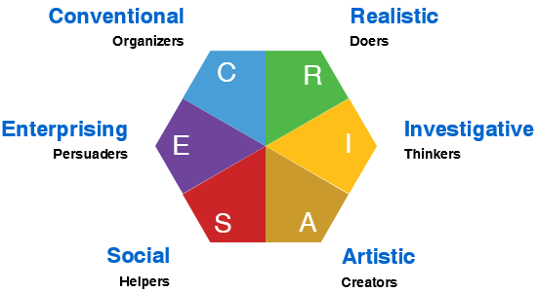

### Realistic - R (Doers)

Like to work with their hands and focus on things in the physical world & use physical skills. Like to repair and work with tools, machines, or animals; outdoor work is often preferred. Prefer problems that are concrete rather than abstract; want practical solutions that can be acted out. Characteristics include stable, assertive, physical strength, practical.  
**Holland typology:** realistic practical frank nature lover curious concrete selfcontrolled ambitious persistent athletic mechanical thrifty stable reserved independent systematic.

### Investigative - I (Thinkers)

Tend to focus on ideas. Like to collect and analyze data and information of all kinds. Curious and tend to be creative and original. Task oriented and motivated by analyzing and researching. Tend to prefer loosely structured situations with minimal rules or regulations. Prefer to think through rather than act out problems. Characteristics include reserved, independent, analytical, logical.  
**Holland typology:** investigative inquisitive scientific precise cautious self-confident reserved independent analytical observant scholarly curious introspective broad-minded logical.

### Artistic - A (Creators)

Creative and tend to focus on self-expression through all kinds of mediums: materials, music and words, as well as systems and programs. Able to see possibilities in various settings and are not afraid to experiment with their ideas. Like variety and tend to feel cramped in structured situations. Deal with problems in intuitive, expressive, and independent ways. Tend to be adverse to rules. Characteristics include intuitive, creative, expressive, unconventional.  
**Holland typology:** artistic creative imaginative unconventional independent original impulsive courageous complicated nonconforming intuitive innovative emotional expressive introspective sensitive open idealistic.

### Social - S (Helpers)

Concerned with people and their welfare. Tend to have well developed communications skills and like to help, encourage, counsel, guide, train, or facilitate others. Enjoy working with groups or individuals, using empathy and an ability to identify and solve problems. Value cooperation and consensus. Deal with problems through feelings. Flexible approach to problems. Characteristics include humanistic, verbal, interpersonal, responsible.  
**Holland typology:** social friendly idealistic outgoing cooperative responsible kind persuasive patient helpful insightful understanding generous forgiving empathetic.

### Enterprising - E (Persuaders)

Work with and through people, providing leadership and delegating responsibilities for organizational and/or financial gain. Goal-oriented and want to see results. Tend to function with a high degree of energy. Prefer business settings, and often want social events to have a purpose beyond socializing. Attack problems with leadership skills. Decision-Maker. Characteristics include persuasive, confident, demonstrate leadership, interest in power/status.  
**Holland typology:** enterprising self-confident sociable enthusiastic adventurous impulsive inquisitive talkative spontaneous assertive persuasive energetic popular ambitious optimistic extroverted.

### Conventional - C (Organizers)

* Like to pay a lot of attention to detail and organization, and prefer to work with data, particularly in the numerical, statistical, and record-keeping realm. Have a high sense of responsibility, follow the rules, and want to know precisely what is expected. Prefer clearly defined, practical problems and to solve problems by applying rules. Oriented to carrying out tasks initiated by others. Characteristics include conscientious, efficient, concern for rules and regulation, orderly.  
  **Holland typology:** conventional well-organized accurate numerically-inclined methodical efficient orderly thrifty structured ambitious persistent conscientious conforming practical systematic polite obedient.

***Epistemology of Engineering Design***

**Design as activity** is related to the conceptualization (pre-execution) stages of making new products. Design as activity is usually further organized under “art versus technique” or “form versus function”. Fine art, industrial design (applied art), architecture and engineering are typical examples of design as activity.

**Design as planning** is related to the systematic mental processes prior to actions and conceptualization (pre-execution) stages for planning composing and decision making. While design as activity is more related to professional endeavors like art or engineering, design as planning is more affiliated with management of a wide range of fields from business to military and from hospitals to academy.

**Design as epistemology** is related to the synthetic methodologies needed for the mental apprehension of appropriateness for change. Design epistemology is distinct from analytic methodologies, which is crucial to develop scientific initiatives.

Taking as a reference the proposed four-dimensional model and the epistemology of design briefly discussed in the previous section, the remainder of the talk analyses the epistemology of engineering in light of the four key questions of the philosophy of knowledge: the ontological, the epistemological, the methodological, and the axiological questions.

For the case of engineering, the ontological question inquires about what reality can engineering know, the epistemological question looks into what is engineering knowledge, the methodological question asks how can engineering knowledge be built, and the axiological question (which includes the ethical question), inquires about the worth and value of engineering knowledge. The talk answers these questions in the context of the proposed model.

It also stresses the key distinctive features of engineering knowledge that emerge from the strong presence of a design dimension. This includes the importance attached to abductive reasoning and the acceptance of courses of action that seize upon chance information, adopt capricious ideas, and provoke creative leaps that seem to go against traditional scientific rigour.

In this respect, Popper’s concept of ‘critical discussion’ will be used to illustrate how the epistemology of engineering can derive final and verifiable rigour from such apparently unsystematic, imprecise, and even random, intermediate steps.

***Rigour, Creativity and Change in Engineering***

Engineers’ drive for innovation can be significantly curtailed by the “bottom line” finances available. Obtaining parts for experimentation in practically zero time can require very resourceful effort because the rigid systems in place for parts procurement too often have been established primarily for production and “just-in-time” receipt. One partial solution is obtaining “samples,” but these are sometimes unreliable parts—and a single failure can result in quick dismissal of a project by management. Rigorous design rules, such as parts derating, design reviews (Preliminary Design Reviews, Critical Design Reviews, and Final Design Reviews) and many “-ilities” are important. But with tight constraints on schedules and finances they often severely limit time for experimentation.

Suggestions:

• Make a list of solutions very early in the design process. This would certainly include the solution proposed, but might have variants that could be more or less innovative, and might save cost.

• Most design efforts involve team effort and the ability to compromise, combined with the resolve to do right. Sometimes you can get your wishes met by just ‘floating” an idea and letting others scramble to take credit for it.

• Keep the design as simple as possible.

• Try to anticipate how the design will look when released to production. Will it survive the test of time going forward with minimal Engineering Change Orders and compromises?

• Will it fill a requirement that could be adapted to some future upgrade with minimal interface changes? Can we fill this space with something better in the future?

• Discuss your ideas with others in various disciplines outside of engineering to get their inputs: project management, QA, reliability, manufacturing, etc.

• Make the first meeting with the customer exciting by showing solutions considered and even making “mock-ups” of what the product might look like. Make sure the customer understands your interpretation of what they want. Sometimes there is wide difference between the written word and what they really need. Get changes in writing!

• Be practical about where parts can be obtained. Try to insure that sample parts are reasonably reliable and not counterfeit, or rejects.

Finally: remember that not all projects will be overwhelmingly successful. Some are praiseworthy but flawed concepts while others may be inadequately funded. But while you cannot be responsible for everything that happens, never let distractions interfere with your next good idea.